TITLE: QSRAC: A Quantum-Safe, Risk-Adaptive, Stateful Access Control Framework with Cryptographic Continuity and Atomic Enforcement
ABSTRACT
Modern access control systems fail to tightly bind identity, runtime risk, and authorization state, resulting in vulnerabilities such as replay attacks, session tampering, and time-of-check-to-time-of-use (TOCTOU) inconsistencies. This paper presents QSRAC, a quantum-safe, risk-adaptive access control framework that integrates post-quantum cryptography, machine learning-based anomaly detection, and a cryptographically evolving authorization state.
The system employs lattice-based key encapsulation and signature schemes to ensure quantum resistance, while an Isolation Forest model dynamically evaluates contextual risk. Authorization continuity is enforced through a hash-chain-based envelope mechanism, and a Redis Lua-based atomic state transition ensures strict sequence integrity and eliminates race conditions. Trust is modeled using an exponential decay function and can be restored via a secure multi-factor authentication (MFA) state repair mechanism.
Experimental evaluation demonstrates strong separation between normal and attack behavior, achieving a false positive rate of approximately 6.5% and zero false negatives under controlled adversarial scenarios. The proposed framework provides a unified, verifiable, and adaptive security model suitable for next-generation zero-trust environments.
KEYWORDS
Post-Quantum Cryptography, Risk-Adaptive Access Control, Zero Trust Security, Isolation Forest, Replay Attack Prevention, TOCTOU Mitigation, Stateful Authorization, Trust Decay
INTRODUCTION
Background
Traditional access control models such as Role-Based Access Control (RBAC) and Attribute-Based Access Control (ABAC) operate on static policies and assume stable trust once authentication is completed. However, modern distributed systems—particularly cloud, IoT, and zero-trust environments—require continuous verification due to dynamic threat conditions. At the same time, the emergence of quantum computing threatens classical cryptographic primitives, making current authentication mechanisms vulnerable to future decryption attacks .

Motivation
Recent research highlights three critical weaknesses in existing systems:
- Lack of runtime risk awareness in authorization decisions
- Absence of state continuity, enabling replay and session tampering
- Exposure to TOCTOU vulnerabilities due to non-atomic enforcement
While Risk-Adaptive Access Control (RAdAC) introduces dynamic decision-making and Post-Quantum Cryptography (PQC) ensures future security, these approaches are typically implemented in isolation. There is no unified system that binds identity, runtime context, and authorization state into a single verifiable structure.

Problem Statement
Current access control frameworks fail to enforce continuous, stateful, and cryptographically verifiable authorization, resulting in:
- Replay attacks due to stateless session handling
- Inconsistent decisions caused by TOCTOU race conditions
- Lack of binding between identity, context, and authorization outcomes

Research Gap
From the literature, the following gaps are identified:
- PQC integration is limited to handshake-level security, not runtime authorization
- RAdAC systems lack cryptographic enforcement of decision continuity
- Existing session mechanisms do not provide tamper-evident state evolution
- Atomic enforcement techniques are not systematically applied to access control state

Objectives of the Study
This work aims to:
- Design a quantum-safe access control framework using PQC primitives
- Integrate ML-based runtime risk scoring into authorization decisions
- Enforce state continuity using cryptographic hash chaining
- Eliminate TOCTOU vulnerabilities through atomic state transitions

Contributions of the Paper
The key contributions of this work are:
- A cryptographically evolving authorization state machine binding identity, risk, trust, and context per request
- A hash-chain-based continuity model ensuring replay-safe session evolution
- Integration of Isolation Forest-based anomaly detection for real-time risk scoring
- A Redis Lua-based atomic enforcement mechanism eliminating race conditions
- A trust decay model with MFA-based state repair, enabling adaptive security recovery

LITERATURE REVIEW
5.1 Post-Quantum Cryptography in Access Control
The transition from classical cryptography to Post-Quantum Cryptography (PQC) is driven by the threat of cryptographically relevant quantum computers (CRQCs), which can break RSA and ECC through algorithms such as Shor’s algorithm. Recent standardization efforts by NIST have identified lattice-based schemes, particularly ML-KEM (Kyber) and ML-DSA (Dilithium), as practical candidates for secure communication .
Kyber provides efficient key encapsulation with low latency suitable for session establishment, while Dilithium enables quantum-resistant authentication. Empirical studies show that PQC schemes can achieve near-comparable performance to classical elliptic-curve systems under realistic network conditions. However, a major limitation is the increased key and signature size, which impacts bandwidth and system scalability.
Gap: Existing research primarily focuses on cryptographic primitives and TLS integration, with limited exploration of PQC in stateful, per-request authorization systems.

5.2 Risk-Adaptive Access Control and Zero Trust
Risk-Adaptive Access Control (RAdAC) extends traditional RBAC and ABAC by incorporating runtime risk into decision-making. Within Zero Trust Architecture (ZTA), access decisions are continuously evaluated based on contextual signals such as device posture, location, and behavioral patterns.
Recent models, including dynamic trust-based frameworks, demonstrate improved flexibility and fine-grained control compared to static policies. Systems like AT-ZTAC combine attribute-based policies with trust scoring to achieve high decision throughput and accuracy.
Despite these advances, current RAdAC implementations:
- rely on logical or policy-based enforcement, not cryptographic guarantees
- lack mechanisms for state continuity across requests
Gap: Absence of a cryptographically enforced linkage between sequential authorization decisions.

5.3 Machine Learning for Security Decision-Making
Machine learning has become a key component in modern access control systems for anomaly detection and behavioral analysis. Among various approaches, Isolation Forest has gained prominence due to its efficiency and suitability for high-dimensional data.
Unlike traditional methods, Isolation Forest isolates anomalies using random partitioning, resulting in linear time complexity and low memory overhead. It performs effectively in real-time environments such as IoT and network intrusion detection.
However, limitations remain:
- Lack of explainability in anomaly decisions
- Sensitivity to data distribution and contamination rates
Gap: ML-based risk scoring is typically used as an auxiliary signal, not tightly integrated into cryptographic enforcement mechanisms.

5.4 Replay Prevention and Stateful Session Security
Traditional session management mechanisms are largely stateless or weakly stateful, making them vulnerable to replay and session hijacking attacks. Recent research introduces stateful authentication frameworks that bind session behavior to contextual history.
Hash-chain mechanisms have been proposed to ensure tamper-evident communication by linking each message to its predecessor. Additionally, nonce-based systems enforce freshness and prevent reuse of requests.
While effective individually, these approaches are often:
- applied at protocol level (e.g., MQTT, messaging systems)
- not integrated into authorization decision pipelines
Gap: Lack of unified stateful authorization models combining replay protection, context binding, and decision continuity.

5.5 TOCTOU Vulnerabilities and Atomic Enforcement
Time-of-Check-to-Time-of-Use (TOCTOU) vulnerabilities arise when system state changes between validation and execution, leading to race conditions and security bypasses. These issues are prevalent in both operating systems and distributed applications.
Atomic execution models, such as Redis Lua scripting, provide a practical solution by ensuring that validation and update operations occur within a single, indivisible transaction. This eliminates race windows and enforces strict consistency.
However:
- Most research focuses on kernel-level protections or database transactions
- Distributed access control systems rarely incorporate atomic state enforcement
Gap: Limited application of atomic mechanisms to authorization state transitions in security systems.

5.6 Trust Modeling and Adaptive Trust Decay
Modern access control systems increasingly treat trust as a dynamic variable rather than a binary attribute. Exponential trust decay models allow trust to decrease over time or in response to risky behavior, enabling continuous evaluation.
Context-aware trust models incorporate factors such as:
- user behavior
- resource sensitivity
- environmental risk
Despite these advancements, current models suffer from:
- lack of standardized trust recovery mechanisms
- inconsistent integration with authorization workflows
Gap: Absence of a formal, system-integrated trust lifecycle combining decay and recovery within secure state transitions.

5.7 Adaptive MFA and Step-Up Authentication
Adaptive Multi-Factor Authentication (MFA) enhances security by triggering additional verification based on contextual risk. Techniques such as WebAuthn and behavioral biometrics improve phishing resistance and continuous authentication.
In modern systems, MFA is evolving from a static login mechanism to a dynamic, risk-triggered process. However:
- excessive MFA prompts can lead to user fatigue
- most implementations focus only on authentication, not state repair
Gap: Lack of integration between MFA and authorization state restoration in a cryptographically enforced system.

5.8 Synthesis of Research Gaps
Across the literature, several cross-domain limitations emerge:
- PQC is not integrated into runtime authorization workflows
- RAdAC lacks cryptographic enforcement and continuity
- ML risk scoring is not bound to secure state evolution
- Replay protection mechanisms are fragmented and protocol-specific
- TOCTOU mitigation is not applied to authorization state transitions
- Trust models lack standardized recovery mechanisms
- MFA is not used as a state repair mechanism

Summary
While significant progress has been made in PQC, RAdAC, ML-based anomaly detection, and atomic systems, these components remain largely isolated. There is a clear need for a unified framework that combines quantum-safe cryptography, adaptive risk evaluation, and stateful authorization continuity, which motivates the design of QSRAC.
METHODOLOGY / PROPOSED SYSTEM
6.1 System Overview
QSRAC is a stateful, risk-adaptive access control framework that integrates post-quantum cryptography, machine learning-based risk scoring, and cryptographic state continuity. The system operates using a two-path architecture:
- Slow Path: Session initialization using PQC (ML-KEM + ML-DSA)
- Fast Path: Per-request authorization using HMAC, ML inference, and Redis Lua atomic enforcement
This separation ensures strong security guarantees without introducing latency in high-frequency authorization decisions.

6.2 System Architecture
The architecture consists of the following components:
- Client Wrapper
  - Handles key exchange (KEM)
  - Maintains sequence number and envelope state
- Middleware
  - Verifies token signature
  - Extracts context
  - Computes risk and trust
- ML Module
  - Generates anomaly score using Isolation Forest
- Envelope Engine
  - Constructs cryptographic state per request
- Redis Lua Engine
  - Enforces atomic state transitions
- Policy Engine
  - Maps risk and trust to access decisions

6.3 Cryptographic Design
Session Establishment (Slow Path)
- Uses ML-KEM (Kyber) for shared key generation
- Uses ML-DSA (Dilithium) for token signing
- Produces:
  - session_key
  - core_token
  - initial hash (init)
Authorization State (Fast Path)
Each request generates a new state:
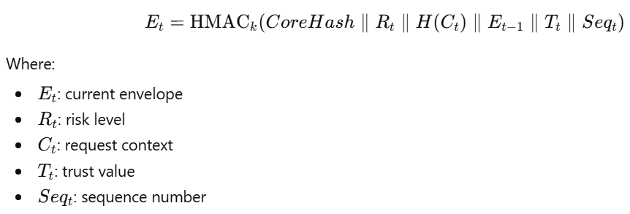
This ensures:
- forward integrity
- tamper detection
- replay resistance

6.4 Context and Risk Computation
Each request includes contextual features:
- request rate
- failed attempts
- geo risk score
- device trust score
- VPN / TOR usage
- sensitivity level
These features are passed to an Isolation Forest model, which outputs an anomaly score mapped to:
- Low
- Medium
- High
- Critical

6.5 Trust Model
Trust evolves dynamically using exponential decay:
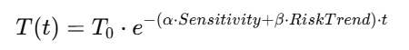
- bounded in ([0,1])
- decreases faster under high risk
- persisted across requests

6.6 Stateful Authorization Flow
For each request:
- Validate token signature
- Extract client state (seq, envelope)
- Verify:
  - sequence continuity
  - hash-chain integrity
- Compute:
  - risk (ML)
  - trust (decay model)
- Generate new envelope
- Execute Redis Lua gate:
  - validate previous state
  - update state atomically (applies to both allowed and denied requests)
- Apply policy decision
- Return updated state (seq, envelope, risk, trust) to client
Note: State transitions occur for every request, including denied requests, ensuring non-repudiable sequence progression and preventing replay-based probing.
6.7 Atomic State Enforcement (Redis Lua)
The Redis Lua script ensures:
- strict sequence increment
- hash-chain continuity
- atomic validation + update
Properties:
- eliminates TOCTOU
- prevents race conditions
- ensures single source of truth

6.8 Policy Decision Model
Decision is based on:
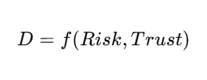
Examples:
- Low risk + High trust → Allow
- Medium risk + Low trust → Step-Up
- High/Critical + Low trust → Block
RBAC and ABAC act as pre-filters, while final decision is dynamic.

6.9 MFA-Based State Repair
When trust falls below threshold:
- system triggers MFA challenge
- client responds using HMAC(session_key)
- upon verification:
  - trust is increased
  - sequence advances
  - hash-chain remains intact
This ensures:
- no bypass of state machine
- secure recovery without reset
Following successful MFA verification, the client synchronizes its local state using the updated sequence number and envelope returned by the server. This ensures continued cryptographic alignment and prevents state desynchronization during subsequent requests.
6.10 Novelty of the Approach
QSRAC introduces the following novel aspects:
- Cryptographically evolving authorization state
- Binding of ML risk to secure state transitions
- Hash-chain enforced session continuity
- Atomic TOCTOU elimination via Redis Lua
- MFA as state repair, not authentication bypass

Summary
The proposed system unifies cryptography, machine learning, and distributed state management into a single framework that ensures continuous, verifiable, and replay-safe authorization.

IMPLEMENTATION / EXPERIMENTAL SETUP
7.1 Tools and Technologies
The QSRAC system is implemented using a modular Python-based stack:
- Backend Framework: FastAPI (API + middleware layer)
- Cryptography Layer: PQC-ready abstraction (Kyber KEM, Dilithium signatures)
- Machine Learning: scikit-learn (Isolation Forest + StandardScaler)
- State Management: Redis (with Lua scripting for atomicity)
- Client Interface: Custom client wrapper (stateful protocol handler)
This modular design enables easy transition from mock cryptography to real PQC implementations.

7.2 System Components Implementation
- Client Wrapper
  - Handles login, KEM key exchange, and session key derivation
  - Maintains:
    - sequence number (seq)
    - envelope hash
  - Attaches context as request headers
- Middleware
  - Verifies token signature
  - Extracts contextual features
  - Computes risk and trust
  - Performs replay and hash-chain validation
- Redis Lua Engine
  - Implements atomic validation:
    - sequence increment check
    - hash-chain continuity
  - Updates session state only on valid transitions
- ML Module
  - Loads trained Isolation Forest model
  - Applies threshold-based mapping to risk levels

7.3 Dataset Description
A synthetic dataset was generated to simulate realistic traffic patterns:
- Normal samples: 800
  - low request rate
  - high device trust
  - minimal failed attempts
- Attack samples: 200
  - high request rate
  - low device trust
  - VPN/TOR usage
  - increased failure counts
The dataset includes contextual features such as:
- request rate
- geo risk score
- sensitivity level
- device trust score

7.4 Model Training
- Algorithm: Isolation Forest
- Configuration:
  - number of estimators: 100
  - contamination: 0.05
- Preprocessing: StandardScaler normalization
The model is trained on combined normal and anomalous data and persisted using joblib.

7.5 Threshold Calibration
Risk levels are derived using percentile-based calibration:
- Low threshold → 70th percentile (normal scores)
- High threshold → 30th percentile (attack scores)
- Medium → midpoint between low and high
Final calibrated values:
- Low: ~ -0.4449
- Medium: ~ -0.5381
- High: ~ -0.6313
These thresholds are stored in a configuration file and used at runtime.

7.6 Experimental Environment
- Execution Mode: Localhost deployment
- Server: FastAPI application
- Client: Python-based wrapper simulating user behavior
- State Store: Redis single-node instance
Requests are simulated with varying contextual parameters to evaluate system behavior under normal and adversarial conditions.

7.7 Evaluation Setup
The system was evaluated across multiple scenarios:
- Normal traffic flow
- High-risk anomalous behavior
- Replay attack attempts
- Sequence tampering
- Envelope tampering
- Concurrent request race conditions
- MFA-triggered recovery
Each scenario was executed using dedicated test scripts to validate correctness and robustness.

7.8 Logging and Monitoring
- Events are recorded in an append-only audit log
- Logged parameters include:
  - session ID
  - decision
  - risk level
  - trust score
Logging is performed asynchronously to avoid impacting request latency.

Summary
The implementation demonstrates a fully functional, modular system capable of simulating real-world access control scenarios with integrated ML, cryptography, and atomic state enforcement.

RESULTS AND DISCUSSION
8.1 Performance Metrics
The system was evaluated using standard anomaly detection metrics:
Metric | Value
False Positive Rate (FP) | 6.5%
False Negative Rate (FN) | 0%
Normal Mean Score | -0.4649
Attack Mean Score | -0.6185
These results indicate strong separation between normal and anomalous behavior, with minimal misclassification.

8.2 Risk Distribution Analysis
Risk Level | Total | Normal | Attack
Low | 240 | High concentration | Minimal
Medium | 508 | Majority normal | Some overlap
High | 192 | Rare | Significant
Critical | 60 | None | Majority

The distribution shows that attack samples are predominantly classified as High or Critical, while normal samples remain in Low and Medium ranges.

8.3 Score Distribution (Graph)
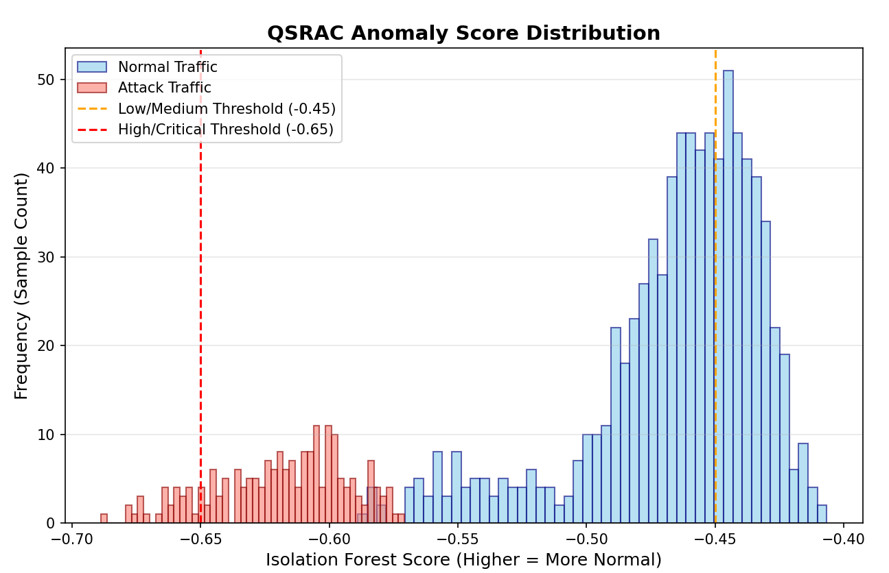Observation:
- Clear separation between normal and attack score ranges
- Threshold boundaries effectively partition risk levels
- Minimal overlap reduces false positives

8.4 Trust Decay Behavior (Graph)
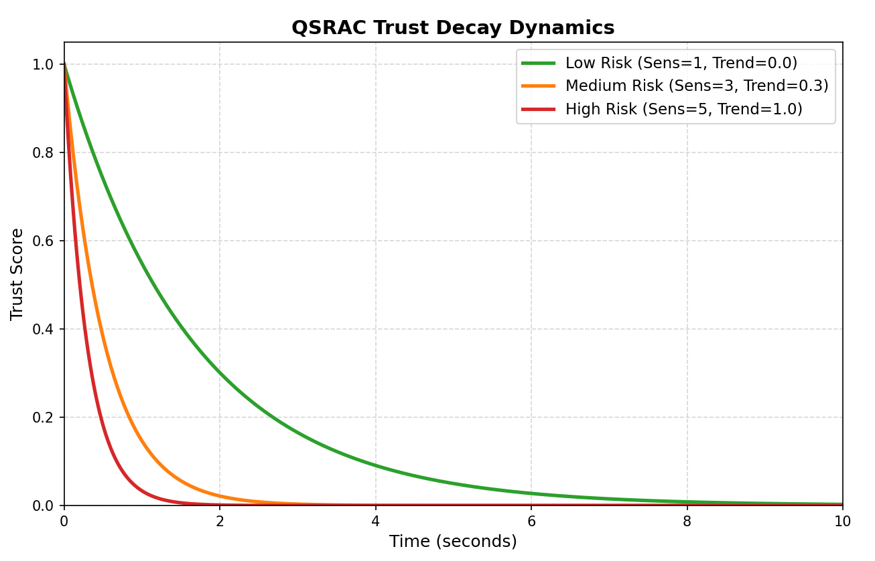Observation:
- Trust decreases exponentially over time
- Higher risk accelerates decay
- Enables detection of gradual behavioral drift

8.5 Security Validation
The system was tested against multiple adversarial scenarios:
Attack Type | Result
Replay Attack | Blocked
Sequence Tampering | Blocked
Envelope Tampering | Detected
Race Condition | Prevented (atomic Lua)
MFA Bypass Attempt | Prevented
These results confirm that the system enforces state continuity and integrity under adversarial conditions. All denied requests were observed to advance the authorization state, preventing reuse of prior cryptographic states.MFF

8.6 TOCTOU Mitigation
The use of Redis Lua scripting ensures:
- atomic validation and update
- no race window between check and use
This eliminates TOCTOU vulnerabilities that are common in distributed access systems.

8.7 System Advantages
- Stateful security: every request is cryptographically linked
- Replay resistance: enforced via sequence + hash-chain
- Adaptive decisions: ML-driven risk + trust model
- Atomic enforcement: eliminates race conditions
- Recovery capability: MFA restores trust without breaking state

8.8 Discussion
The results demonstrate that QSRAC effectively combines:
- PQC for secure identity
- ML for dynamic risk evaluation
- stateful cryptographic continuity for enforcement
The zero false negative rate indicates strong detection of malicious behavior, while the low false positive rate maintains usability.
However, the evaluation is currently based on synthetic data, and further validation on real-world datasets is required for broader generalization.

CONCLUSION
This paper presented QSRAC, a quantum-safe, risk-adaptive access control framework that unifies post-quantum cryptography, machine learning-based risk scoring, and cryptographically enforced stateful authorization. The system addresses key limitations of traditional access control models by binding identity, runtime context, risk, and trust into a continuously evolving authorization state.
Through the use of lattice-based cryptographic primitives, QSRAC ensures resistance against future quantum threats. The integration of Isolation Forest enables real-time anomaly detection, while the hash-chain-based envelope mechanism enforces forward integrity and replay resistance. The adoption of Redis Lua scripting provides atomic state transitions, effectively eliminating TOCTOU vulnerabilities in distributed environments.
Experimental evaluation demonstrates strong performance, achieving low false positive rates and zero false negatives under controlled adversarial scenarios. Additionally, the system successfully withstands replay attacks, sequence tampering, and race conditions, validating its robustness.
Overall, QSRAC establishes a unified, verifiable, and adaptive security model suitable for modern zero-trust architectures, where continuous validation and cryptographic integrity are essential.

FUTURE WORK
While QSRAC demonstrates strong performance and security guarantees, several areas remain for further exploration:
- Real-World Dataset Validation
Evaluate the system on production-scale datasets to improve generalization and robustness of ML thresholds
- Deployment of Full PQC Stack
Integrate production-grade Kyber and Dilithium implementations using optimized libraries (e.g., OpenSSL with liboqs)
- Distributed State Management
Extend Redis-based atomic enforcement to clustered or distributed environments while maintaining consistency guarantees
- Explainable AI for Risk Decisions
Incorporate explainability mechanisms to interpret anomaly scores and improve auditability
- Advanced Adversarial Testing
Evaluate resilience against adversarial ML attacks and sophisticated multi-stage attack patterns
- Performance Optimization for Edge Systems
Adapt the system for resource-constrained environments such as IoT and edge devices
REFERENCES (IEEE Style)
[1] NIST, “CRYSTALS-Kyber (ML-KEM) and CRYSTALS-Dilithium (ML-DSA) Standards,” FIPS 203 & FIPS 204, 2024.
[2] J. Beadle, “Post-Quantum Cryptography for Secure Communication, IoT, and Blockchain,” Beadle Scholar, 2023.
[3] A. Alagic et al., “Status Report on the Second Round of the NIST Post-Quantum Cryptography Standardization Process,” NIST, 2020.
[4] M. Kannwischer et al., “Performance Analysis of Post-Quantum Cryptography Algorithms,” arXiv preprint, 2023.
[5] M. Scott et al., “Efficient Unified Hardware Architecture for Post-Quantum Cryptography,” IEEE Access, 2024.
[6] Teleport, “Risk-Adaptive Access Control (RAdAC): A Deep Dive,” 2023.
[7] S. Rose et al., “Zero Trust Architecture,” NIST Special Publication 800-207, 2020.
[8] X. Chen et al., “A Zero-Trust Access Control Model Based on Attribute and Dynamic Trust,” MDPI Sensors, 2023.
[9] IEEE, “Integrating Zero Trust Architecture in O-RAN: A Comprehensive Survey,” IEEE Xplore, 2024.
[10] F. T. Liu et al., “Isolation Forest,” IEEE ICDM, 2008.
[11] Y. Li et al., “Unsupervised Anomaly Detection for IoT Devices Using Isolation Forest,” arXiv, 2022.
[12] H. S. Kim et al., “Anomaly Detection Using Isolation Forest and Autoencoder Models,” PMC, 2023.
[13] A. Perrig et al., “Stateful Authentication Framework for Secure IoT Systems,” 2023.
[14] UBC Research, “Enhancements of Agent-to-Agent Communication Framework Using Stateful Security,” 2024.
[15] HexHive, “Midas: Systematic Kernel TOCTOU Protection,” 2022.
[16] Redis Labs, “Atomic Operations Using Lua Scripting in Redis,” 2023.
[17] SentinelOne, “Redis Lua Script RCE Vulnerability (CVE-2024-46981),” 2024.
[18] OneUptime, “Designing Atomic Systems with Redis and Lua,” 2023.
[19] R. Shaikh et al., “Adaptive Trust-Decay Models for Cybersecurity,” ResearchGate, 2022.
[20] IBM, “Adaptive Multi-Factor Authentication (MFA),” 2023.
[21] SentinelOne, “Adaptive MFA and Phishing-Resistant Authentication,” 2023.
[22] PMC, “Multi-Factor Authentication in Internet of Healthcare Things,” 2022.

